Mali

## Respect for rule of law (ROL) data

The data set shows the data on the respect of the rule of law for the country.

## # A tibble: 19 x 5  
## country iso3c date ruleOfLaw ruleOfLawCategory4   
## <chr> <chr> <dbl> <dbl> <chr>   
## 1 Mali MLI 1996 -0.297 ROL moderately disrespected  
## 2 Mali MLI 1998 -0.346 ROL moderately disrespected  
## 3 Mali MLI 2000 -0.347 ROL moderately disrespected  
## 4 Mali MLI 2002 -0.233 ROL moderately disrespected  
## 5 Mali MLI 2003 0.000189 ROL moderately respected   
## 6 Mali MLI 2004 -0.187 ROL moderately disrespected  
## 7 Mali MLI 2005 -0.157 ROL moderately disrespected  
## 8 Mali MLI 2006 -0.290 ROL moderately disrespected  
## 9 Mali MLI 2007 -0.183 ROL moderately disrespected  
## 10 Mali MLI 2008 -0.321 ROL moderately disrespected  
## 11 Mali MLI 2009 -0.365 ROL moderately disrespected  
## 12 Mali MLI 2010 -0.450 ROL moderately disrespected  
## 13 Mali MLI 2011 -0.501 ROL moderately disrespected  
## 14 Mali MLI 2012 -0.671 ROL moderately disrespected  
## 15 Mali MLI 2013 -0.749 ROL moderately disrespected  
## 16 Mali MLI 2014 -0.644 ROL moderately disrespected  
## 17 Mali MLI 2015 -0.735 ROL moderately disrespected  
## 18 Mali MLI 2016 -0.782 ROL moderately disrespected  
## 19 Mali MLI 2017 -0.777 ROL moderately disrespected

## Respect for rule of law (ROL) trend

The plot shows the trend of the respect for the rule of law for the country.

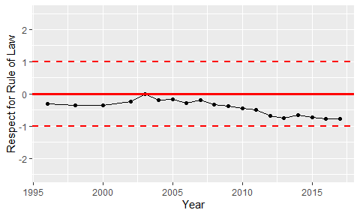

Trend of the Respect for the Rule of Law